Properties of BCC iron

Formation energy of vacancies [1]

Density – ρ $= 16.6$ g/cm3

Molar mass M= 55.85 g/mol

Molar volume – 16.6/55.85 mol/cm^3

Atomic density - 16.6/55.85/N_A mol/cm^3 = 1.7899291e+23 atoms/cm^3

Atomic volume = 1/1.7899291e+23 cm^3/atom*1e7^3 nm^3/cm^3 = 0.00559 nm^3/atom

D = 1.39 exp(-240200/RT+1.6/(kbT)) cm^2/s[2]

Surface energy – 2.25 J/m^2 [3]

$κ=3\sqrt{2}γδ$

$w=3\sqrt{2}\frac{γ}{δ}$

$L=\frac{M}{3\sqrt{2}δ}$

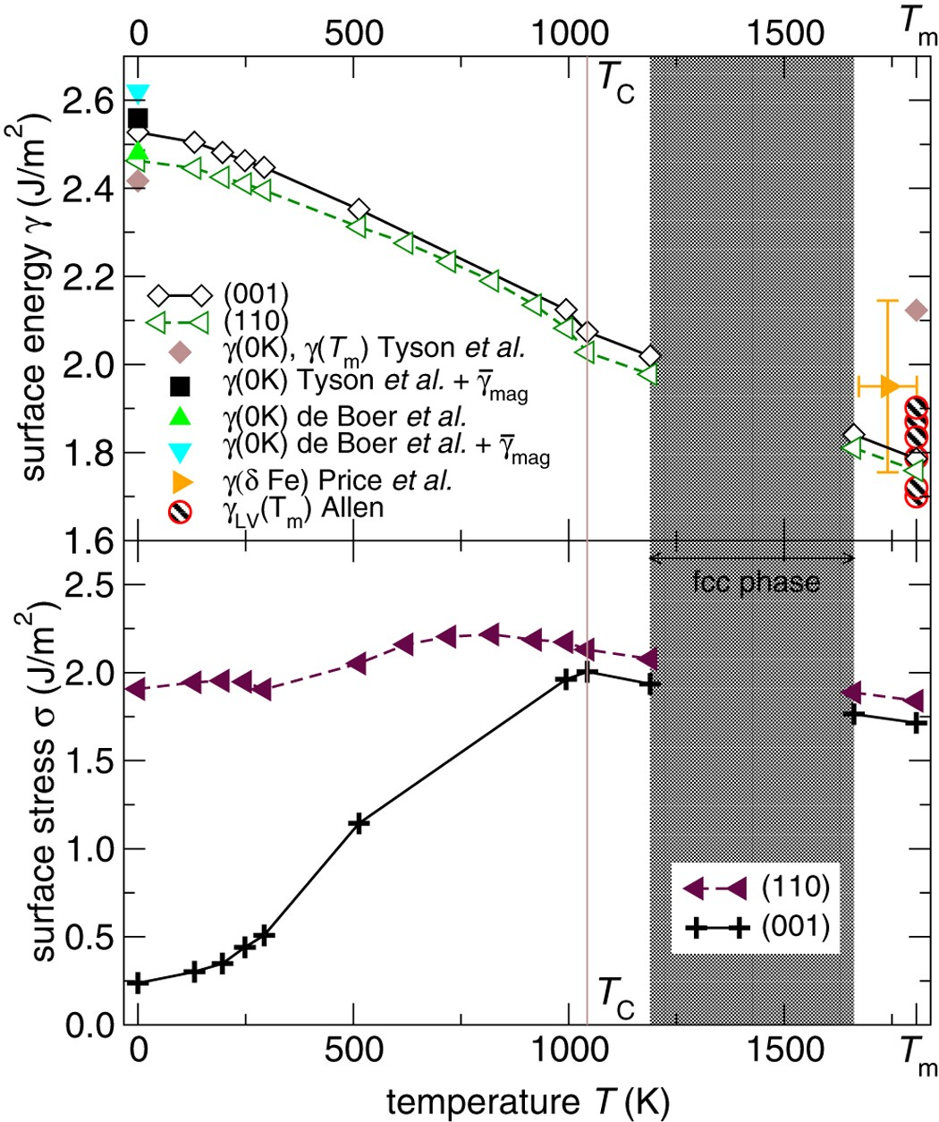

[1] H. Matter, J. Winter, W. Triftshäuser, Phase transformations and vacancy formation energies of transition metals by positron annihilation, Appl. Phys. 20 (1979) 135–140. https://doi.org/10.1007/BF00885934.

[2] M.I. Mendelev, Y. Mishin, Molecular dynamics study of self-diffusion in bcc Fe, Phys. Rev. B. 80 (2009) 144111. https://doi.org/10.1103/PhysRevB.80.144111.

[3] S. Schönecker, X. Li, B. Johansson, S.K. Kwon, L. Vitos, Thermal surface free energy and stress of iron, Sci. Rep. 5 (2015) 14860. https://doi.org/10.1038/srep14860.